How to Efficiently Utilize the Automation Test Estimation, Test Delivery Planner and ROI Calculator Template:

Navigate to the "Input Parameters" sheet and input your data (highlighted in green | Screenshot below)

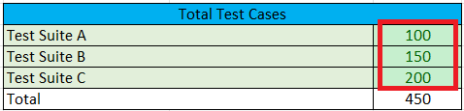

* Specify the total number of test cases per suite in the 'Total Test Cases' section, categorized by test suites. (Screenshot Below)



* Assess the distribution of the complexity of test cases to align with your project's requirements; adjust as needed. (Note: This may vary across projects. | Screenshot Below)

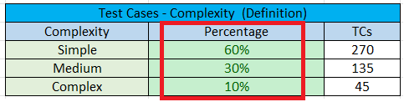

* Include the count of Test Automation engineers involved in the project and indicate their respective capacities and contingency. (Screenshot Below)

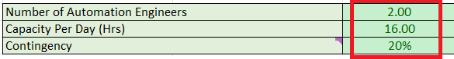

* Depending on the chosen automation tool, input the development time for test cases based on their complexity. (Note: This can vary between projects | Screenshot Below)

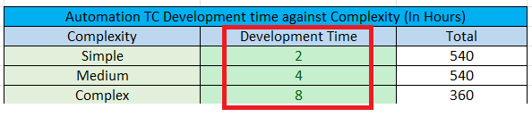

* Enjoy.

The Manual execution efforts Calculated. (InputParameters sheet)

# 

Total TC development time, expected throughput, expected sprints and ROI/TC. (InputParameters sheet)

Automated TC Delivery Plan + Calculated ROI per sprint (TC Development Plan + ROI)

Ready to consume graph (TC Development Plan & ROI)

